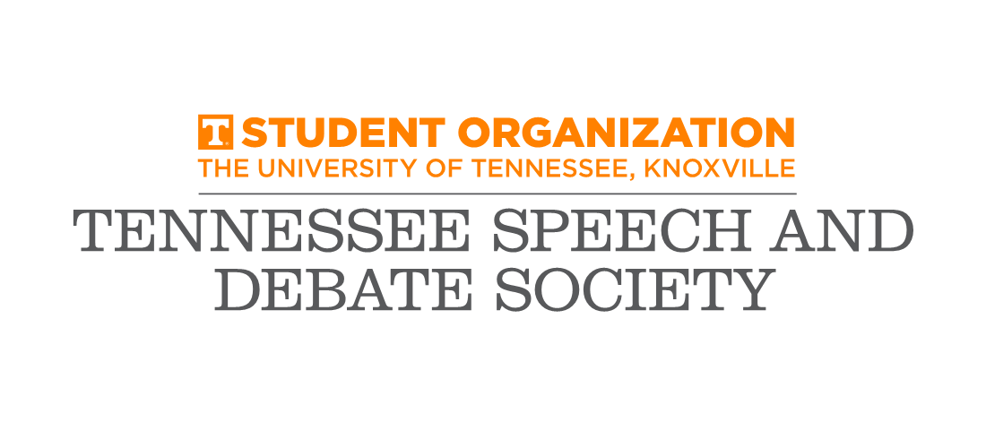

2019 VOL Classic

The University of Tennessee-Knoxville

February 2-3, 2019

Esteemed Debaters and Colleagues,

The Tennessee Speech and Debate Society of the University of Tennessee at Knoxville would like to cordially invite you and your debate team to attend the University of Tennessee’s VOL Classic on February 2nd and 3rd, 2019.
The tournament will be held on our lovely Knoxville campus, and will include all four divisions (Novice, Junior Varsity, Varsity, and Pro) of IPDA. There will be eight preliminary rounds to provide opportunity and a productive learning experience for all debaters (and also a great opportunity for season-long points!). The TSDS eagerly looks forward to an enjoyable, well-run tournament. We will also be providing free snacks throughout the tournament for the convenience and enjoyment of your teams and debaters.
We are eager to see many great debaters and teams gather together for a weekend of exemplary debate. This tournament should be a wonderful event for new and veteran debaters. In addition, we encourage everyone to bring as many judges as possible to diversify the judging pool.
The entire Tennessee Speech and Debate Society is privileged and enthusiastic to once again host the VOL Classic and hopes to welcome you at our Knoxville campus for an exciting weekend of debate.
If you have any questions, please contact us by email or phone. We look forward to seeing you!

Warm regards,
Tennessee Speech and Debate Society

CONTACTS:
Mickayla Stogsdill, President Cole Pawlaczyk, Secretary
(316) 708 - 8261 (989) 984 - 4696
mickayla@utk.edu cole@utk.edu

ENTRY DEADLINES
All teams must register by Tuesday, January 29th at 5pm to utkdebateteam@gmail.com
Any changes must be made by Wednesday, January 30th at 12pm. Any changes after this deadline will warrant a charge of $15 per change.

Hotels
Hotel options are conveniently placed in downtown and immediately surrounding campus areas. Below is a list of nearby hotels:

Hilton Garden Inn (1706 Cumberland Avenue, Knoxville, Tennessee 37916)- (865) 437-5500
Holiday Inn (525 Henley Street Knoxville, Tennessee 37902)- (865) 522-2800
The Oliver Hotel (407 Union Ave SW, Knoxville, TN 37902)- (865) 521-0050
Red Roof Inn (1315 Kirby Rd, Knoxville, TN 37909)- (865) 584-3911
Travelodge (6200 Papermill Dr NW, Knoxville, TN 37919)- (865) 584-8511

Arrival and Registration
Registration will be on the second floor of the Humanities and Social Sciences Building. Like many universities, our room selections will not be finalized until closer to the tournament date, and we will email any more details we have as soon as we have them a couple of days before the tournament. Below is a map of most of campus.
NOTE: Participants/teams/judges not showing up to their rounds is equivalent to an entry being dropped at registration. Thus, please be sure your students and judges attend each of their assigned rounds.

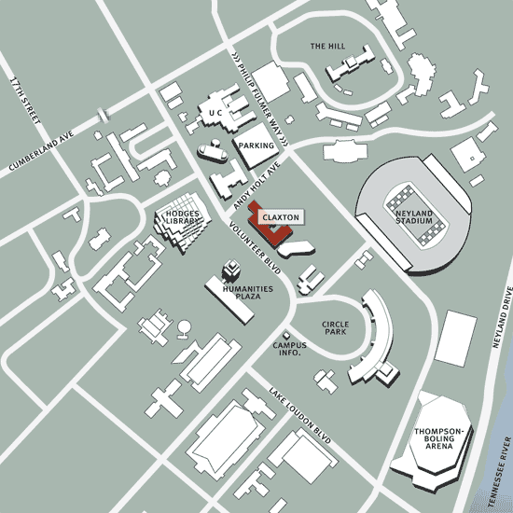
Above, we will be hosting most of the tournament in the “Humanities Plaza”- students know this as the Humanities and Social Sciences Building or HSS.
Parking:
Parking permits will be distributed at registration. UT’s parking staff are very strict- use the pass when you get one! We are working closely with UT’s Parking Department to make this as painless as we can. Parking will be in Circle Park next to “campus info.”
Tentative Schedule:
Saturday, February 2nd
10:00-11:00 Registration
11:15 Draw Round 1 (FLIGHTED ROUNDS: Flight 1: Novice & Pro)
1:00 Draw Round 2
2:45 Draw Round 3
4:30 Draw Round 4
6:15 Draw Round 5
8:00 Draw Round 6

Sunday, February 3rd
8:00 Draw Round 7
9:45 Draw Round 8
11:30 Coaches Review
12:00 Lunch
1:00 Elimination Round 1
2:30 Award in AMB 32
ALL OTHER ELIMINATION ROUNDS ASAP

Fees
IPDA …….……………………………………….…………………$30 per debater
Judges
IPDA…………….……………….……………………1 judge for every 4 debaters
JUDGE FEES (for every uncovered debate slot)…………………..…………$15

PLEASE BRING JUDGES
Judging will be tight (as always)!
Food Provided
SNACKS FOR JUDGES………………………….Throughout the Tournament
UTK has a lot of great dining options on-campus and surrounding campus!

PAYMENT
CASH OR CHECKS ONLY.
Make all checks payable to the Tennessee Speech and Debate Society.

SWEEPSTAKES & AWARDS
We will follow IPDA Rules which can be found here: http://www.ipdadebate.info/constitution--bylaws.html

All advancing debaters will receive awards!

Sweepstakes will follow the following formula:
All wins and byes will be awarded 1 point. Each person breaking to out-rounds will receive 2 points. Speaker awards will count toward sweepstakes points with
1st – 5 points; 2nd – 4 points; 3rd – 3points; 4th – 2 points; 5th – 1 point
Novice, Junior Varsity, Varsity and Professional will count toward the tournament sweepstakes. There is no limit on entries, but only the top three competitors in each division will count toward the sweepstakes. There will be speaker awards for the top 5 competitors from each division in IPDA and sweepstakes for IPDA. The team with the highest winning percentage (minimum 3 competitors) will also receive the “Big Orange Award.”
Dr. Pat Richey, head coach of MTSU, will be running our tab room.

School:
Official Representative:
Address:
Phone (must be able to reach you during the tournament):
Email:

Novice Division:
1.
2.
3.
4.
5.
Junior Varsity Division:
1.
2.
3.
4.
5.
Varsity Division:
1.
2.
3.
4.
5.
Professional Division:
1.
2.
3.
4.
5.
Judges:
1.
2.
Fees: ______ competitor slots @ $25 each = _____

(Please Make Checks Payable To: Tennessee Speech and Debate Society)
Entries can be emailed to Mickayla Stogsdill at utkdebateteam@gmail.com

